**Front-side of Story Card**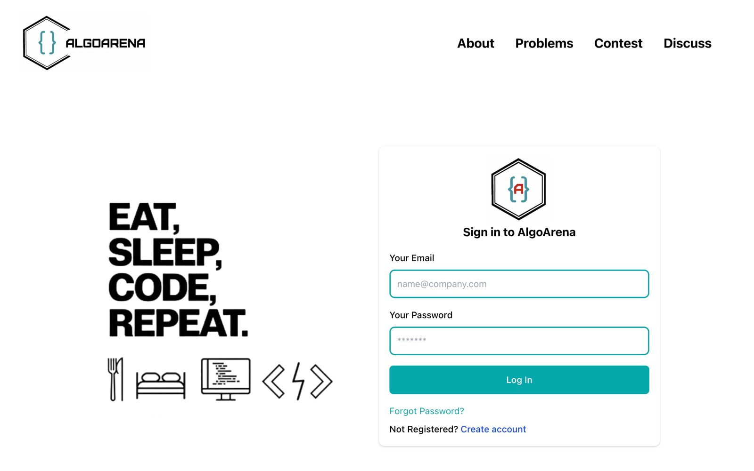

**As a** user,

**I want to** log in using my credentials,

**So that** I can access the platform securely.

**Backside of the story card**

| Success Conditions   * Users can log in with valid credentials. * Invalid credentials show an error message.   Failure Conditions   * Login fails for valid credentials. * Error messages are not shown for invalid credentials. |
| --- |